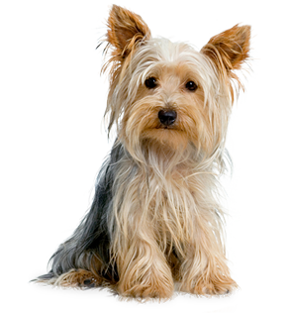
Topsy Tails Mobile Dog Grooming
Topsytails376@gmail.com
0848765139

Grooming Terms and Conditions
Non negotiable conditions under which dogs are accepted for grooming.
- Please make sure your dog(s) is fit and healthy, Grooming of sick or elderly dogs is entirely at owner’s risk. We will not groom a dog that is on antibiotics medication or is under vet supervision while on treatment. Grooming may expose underlying skin or health problems that we cannot be held liable.

- Your dog(s) are vaccinated and is up to date. An unvaccinated dog puts itself and others at risk. We require vaccinated vet books for the first grooming session as well as puppy/puppies first when they will start their grooming session after the last puppy inoculations which is 16 weeks of the age of 4 months old.

- Please clearly understood and agreed that whilst every care and attention given to your dog(s) they are accepted at owner’s risk. We will do our upmost best for your precious pooches grooming experience with care and compassion of the allocated time for the grooming packages with instructions from the owner on the day of the grooming appointment.

- Payment must be paid on completion of your dog. Estimates are based on an average dog of the breed type but owners must remember that some dogs will require extensive extra work and that this will be charged for an hourly basis and owners must paid on time same day.

- Shaving of dogs will dramatically change their appearance and the hair will be very short and close to the skin. This may expose pre-existing skin complaints. Your written permission will be required to shave off a matted coat.

We reserve the right to refuse a dog that presents a risk of injury to itself or staff.

- Under no circumstances do we accept sedated dogs. Please refer to point number 1.

Owner’s Signature _________________________
Date signed_______________________________

